TD 3 DE MATHS

Exo 1

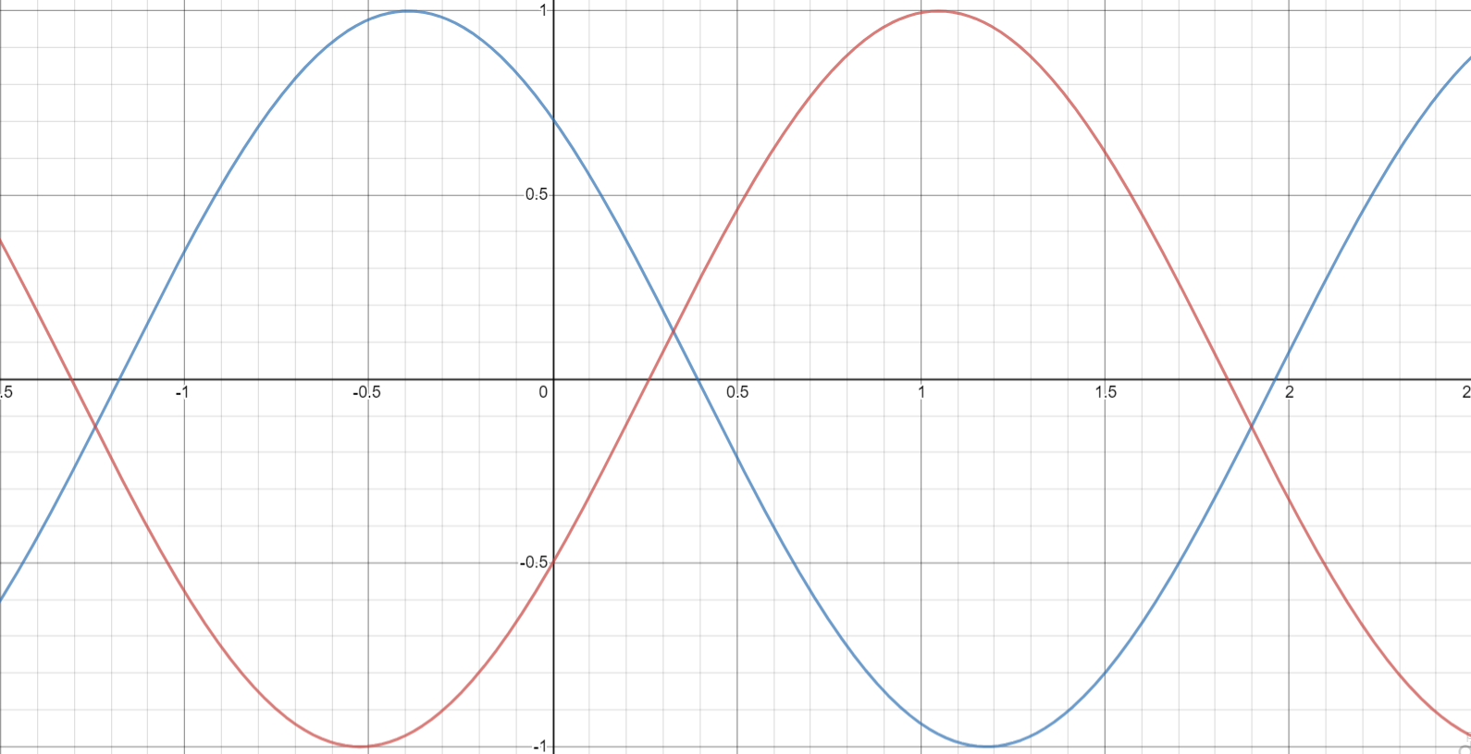

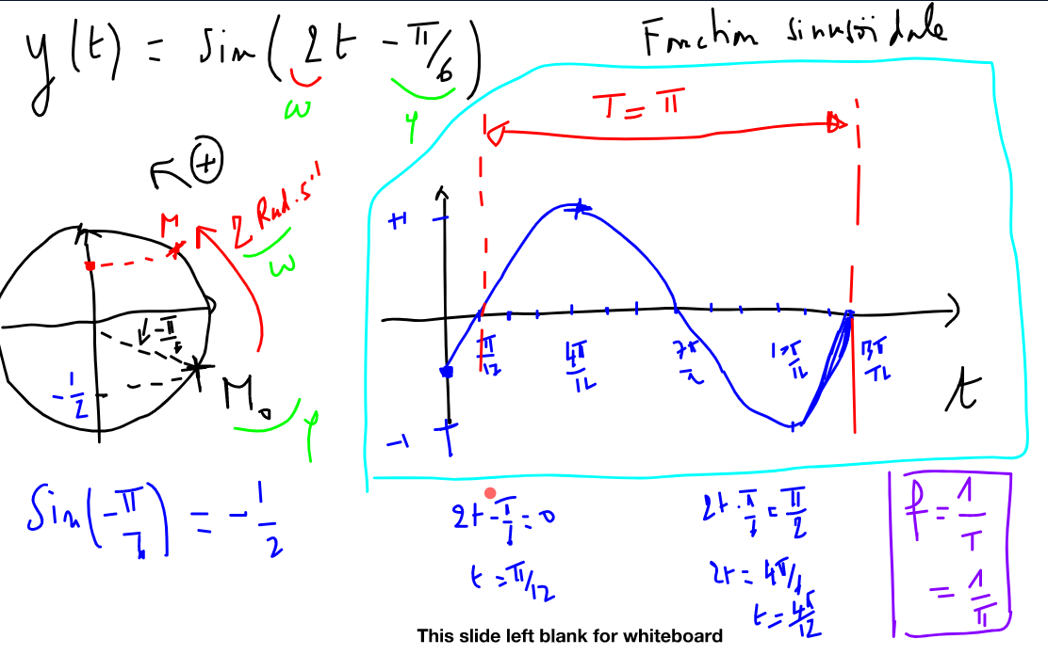

Y = cos (2t + π/4)

Quand t = 0 , y = cos(π/4) = √2/2

Quand y = 0, 2t + π/4 = π/2 donc 2t = π/2 - π/4 donc t = π/8

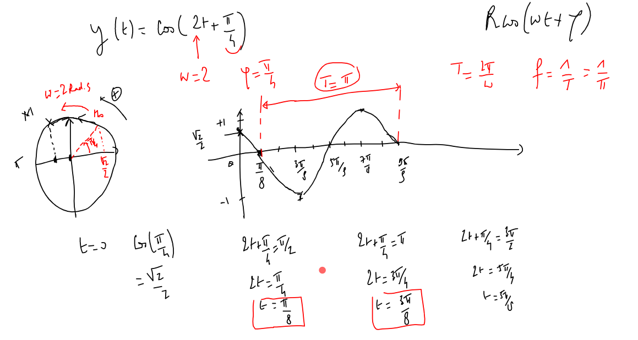

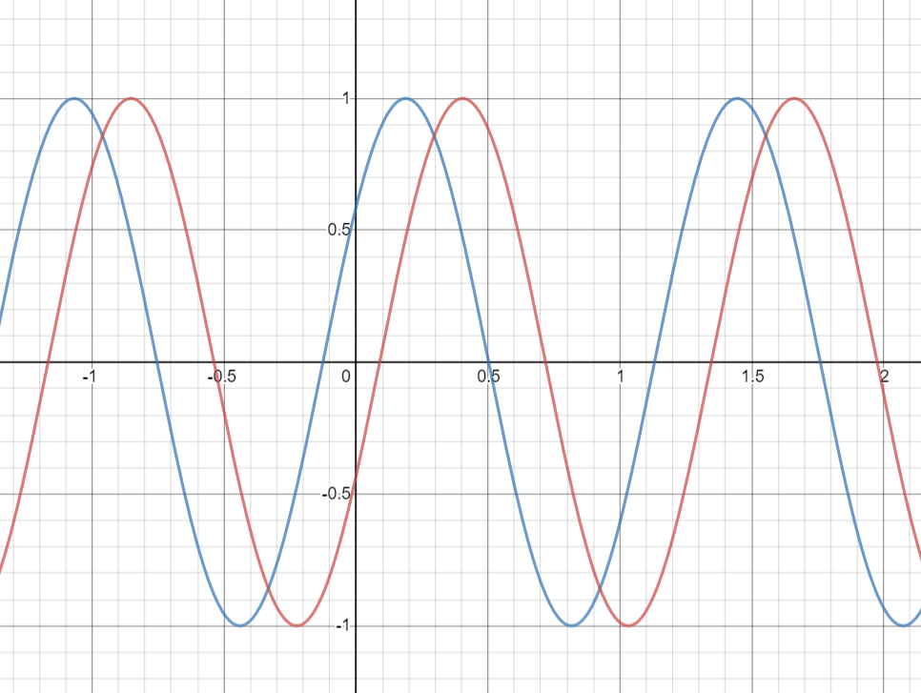

5t + π /5 = π

5t = 4 π/5

t = 4π/25

